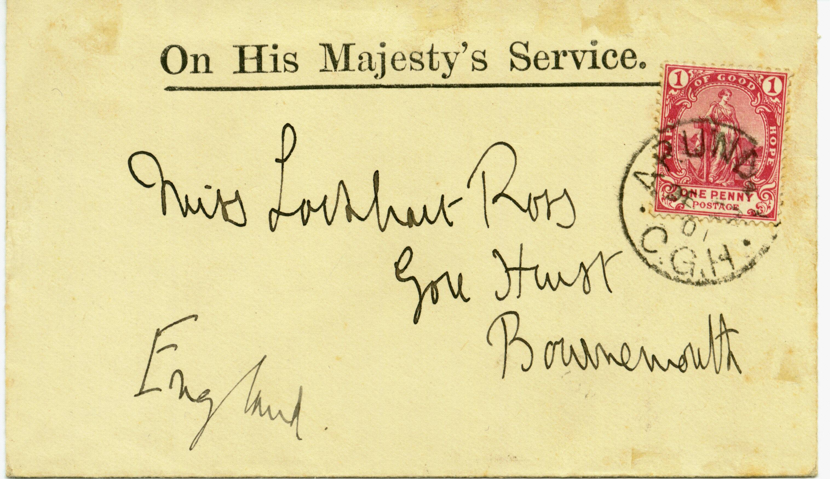
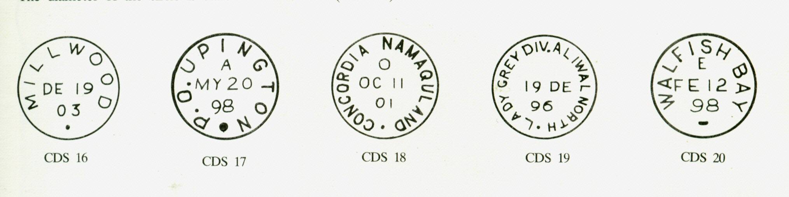
+

THE CIRCULAR C.G.H. DATED STAMPS

The distinctive feature of this datestamp (Goldblatt Type CDS 16 to 20) is the dot at the bottom, approximately 2 mm above the lower curve of the circle. It was put into use in 1885 and was widely distributed to most post offices in the colony. The name of the town appears above and follows the curve of the circle. The month, day and year are in the centre. There is usually a control letter.
Diameter 22 mm
Letters 2.5 mm High
Diameter 22 mm
Letters 2.5 mm High Name Of Town and its Territorial division
Diameter 22 mm
Letters 2.5 mm High
P.O before Name of Town
Diameter 22 mm
Letters 2.5 mm High Name Of Town and its Territorial division
Diameter 22 mm
Letters 2.5 mm High
Dash at Bottom instead of DOT

Cover from Apunda and addressed to England. “APUNDA C.G.H”. cds dated “27 DE 01”. Mail from this post office is extremely rare. CDS resembles
Goldblatt Type 28, but has no control letter. Numbered in this study as CDS 28 (a).

CAPE OF GOOD HOPE

DEVELOPENT OF POSTAL SERVICES

The Circular Dated Stamp

Dot at Bottom
1885

